CL Robot

Hao Tian, Allen Loukiantchenko, Owen Stephenson, Kevin Zhou

**Brief Description of Problem**

There are unorganized objects that we want to sort into their respective coloured bins. We want to create a robot that will help us sort a group of objects and put them into the correct coloured bin located some distance away. The objects will be lined up for the robot to receive.

**Preliminary Ideas**

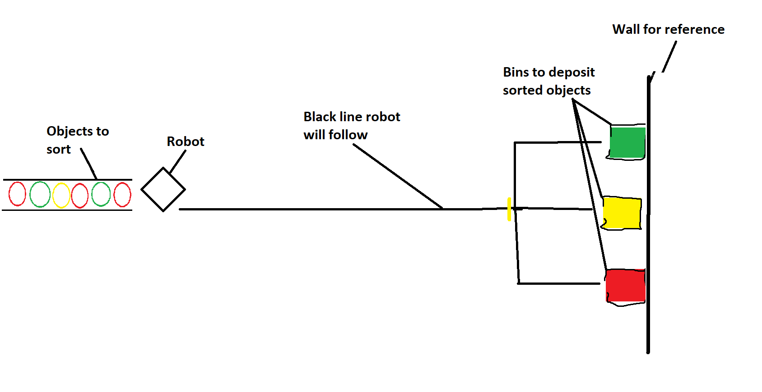

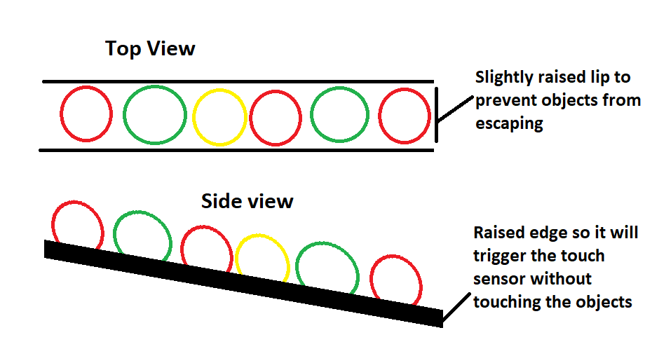

The diagram demonstrates a process to deliver colored objects from one place to its destination. The robot will be set as its front facing objects, and will start moving once any button is pressed . At the place where colored objects are stored, there will be a low obstacle for the robot to detect with its touch sensor and to prevent objects from spreading out from their container, where they are stored in a line. Once the robot bumps on the obstacle the arm will lower down to catch an object then the robot turns 180 degrees back to where the black line is. The robot will follow the black tape with its color sensor until it meets another colored tape, turn the correct direction and finally arrive at the destination and leave the objects there. Then the robot returns to the storage place and repeats the whole process until there are no objects left in the container.

**Motor and Sensor Usage**

Two large motors will be used for the wheels of the robot allowing movement of the robot on the ground.

The medium motor will be used for the arm of the robot and allow the arm to move up and down in order to “grab” the object and bring it to its bin.

A colour sensor is used to sense the colour of the object being delivered so that the robot can deliver it to the correct bin. Another colour sensor will be used so that the robot can know where to turn to head to the correct coloured bin.

A gyro sensor will be used to ensure that the robot turns accurately.

An ultrasonic sensor is used to gauge the distance the robot is from the wall so that the robot can drop off the item at the same area each time.

A touch sensor will be used to ensure that the robot hits the ramp that the objects are stored in so that the robot can reliably pick up the object every time.

**Unusual Features**

For this project the robot will need some sort of arm that can hold and release an object. This arm will need to be constructed as will the mechanism that allows it to move up and down.

**Additional Parts Needed**

* An additional large motor.
* An additional color sensor
* Lego pieces to make the arm and gears for it to interact with a motor
* An additional touch sensor
* Coloured balls to sort
* Coloured bins to put the balls in
* Lego pieces to make the stand for the coloured balls